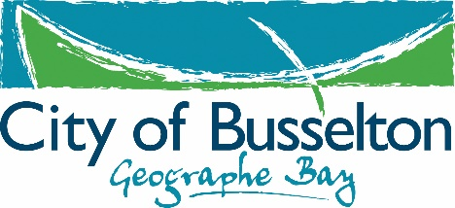
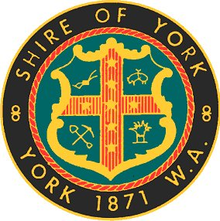

Community Funding
Guidelines 2017/18

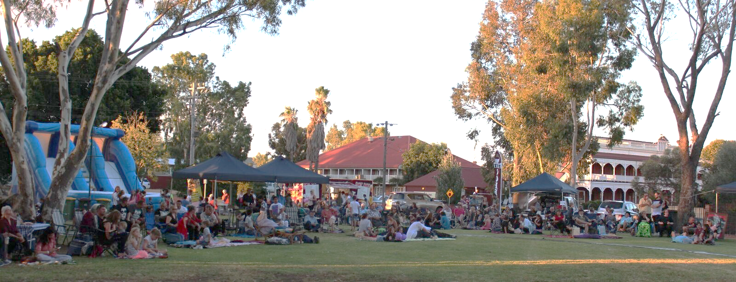
Festival of Sound road safety event - 2016 Community Funding

March 2017

Contents Page

1. Introduction to the Community Bids Program 2
2. Funding Levels 2
3. Eligibility for Community Bids Funding 2
4. Considerations for Funding 3
5. Funding Categories 4
5.1. Community Enhancement 4
5.2. Sport and Recreation Development 4
5.3. Environment Wellbeing 5
6. Funding Conditions 5
6.1. Grant Agreement 5
6.2. Written Quotation 5
6.3. Evaluation Form 5
6.4. Marketing & Promotion 5
6.5. Purpose 6
6.6. Unspent Funds 6
7. How to apply 6
8. Assessment Process 6
9. Successful Applicants 7
9.1. Minor Grants 7
9.2. Major Grants 7
10. Contact 7

- Introduction to the Community Grants & Sponsorship Funding Program
Purpose
The aim of the community funding program is to grant financial assistance to organisations that provide services or activities that align with the Shire’s Strategic Community Plan and deliver sustainable social, environmental and /or economic benefit to the Shire of York community.

- Funding Levels
The Shire of York offers two types of funding to the community:

- Grants & Sponsorship (0 - $10,000)
- Tourism Events Sponsorship ($10,001 +)

- Eligibility for Community Grants & Sponsorship Funding
- Community Funding is available to not for profit groups and organisations located in the Shire of York. However, in special circumstances organisations outside the Shire of York with a proposed project, program or activity to take place within the Shire may be considered if the project is considered to have a significant regional benefit.
- The program/project must be delivered within the Financial Year that the funding is awarded.
- Community groups may submit only one application in each funding round.
- All applications must be submitted on the appropriate Community Funding; Grants & Sponsorship Application Form.
- Community groups/organisations must have an Australian Business Number (ABN) and be Incorporated.

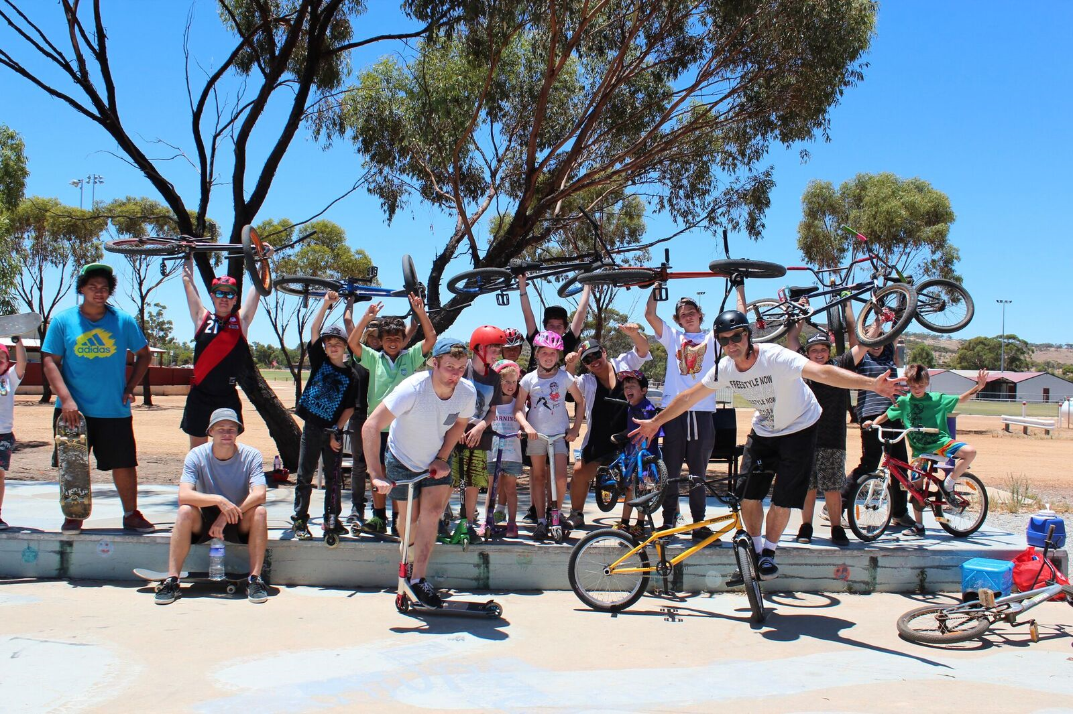
York Youth Skate Park Consultation, Community Funding 2015

- Considerations for Funding
Consideration will be given to the following:
- Community beneficial programs.
- One off projects or activities.
- Equipment grants for durable equipment only.
The following will not be considered for funding:
- On-going operational expenses.
- Consumable equipment.
- Retrospective funding.
- Deficit funding for organisations/groups.
- Facility maintenance.
- Programs, projects and services considered the responsibility of other government departments, individuals and private for-profit groups.
- Activities that do not relate to the Key Focus Areas in the Shire of York’s Strategic Community Plan.
- Applications that are not considered to be complimentary to the services and functions that local government provides will not be eligible.

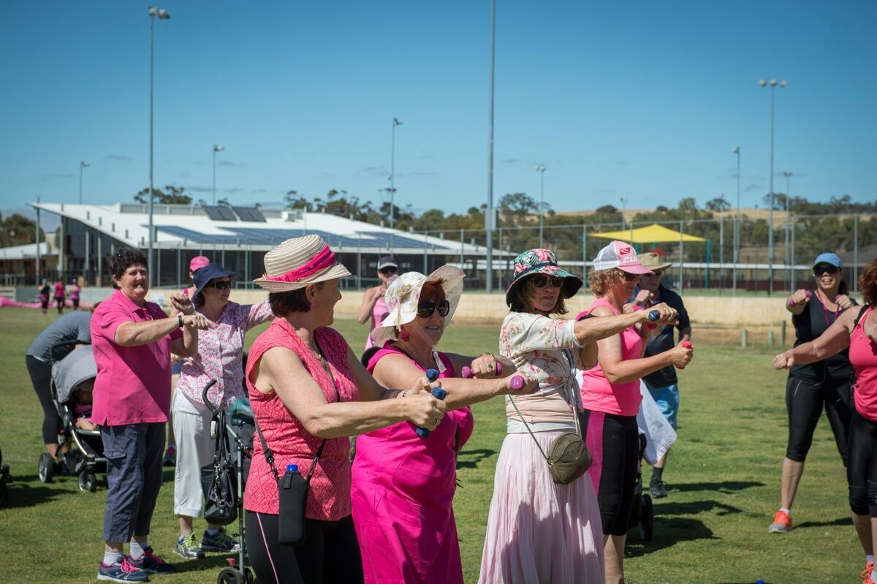
Think Pink Breast Cancer Awareness Walk, Community Funding 2016
- Funding Categories

  - Community Enhancement

Objectives: To support organisations that provide services or activities to any of
the following sectors of the community:
- Aged
- Youth
- Disadvantaged
- Early Childhood & Families
- Volunteers

Strategic Priorities: Community and Social Wellbeing
- Provide a range of quality leisure, cultural, recreation and sporting facilities and services.
- Provide for the youth, the aged and the disadvantaged.
- Provide for a healthy community.

Criteria:
- Strategic Alignment with the Shire of York Strategic Community Plan 2016-2026
- Consultation & Partnerships with the community.
- Demonstrated Need.
- Demonstrated community capacity building.

  - Sport and Recreation Development

Objectives: To provide funding for projects, programs and activities that contribute to
the health, wellbeing and safety of the community.

Strategic Priorities: Community and Social Wellbeing
- Provide a range of quality leisure, cultural, recreation and sporting facilities and services.
- Provide for the youth, the aged and the disadvantaged.
- Provide for a healthy community.

Criteria:
- Strategic Alignment with the Shire of York Strategic Community Plan 2016-2026
- Consultation & Partnerships with the community.
- Demonstrated Need.

  - Environment Wellbeing

Objectives: To provide funding for valuable projects, programs and activities which
protect and enhance the natural and built environment.

Strategic Priorities: Natural and Built Environment Wellbeing
- Manage and enhance our heritage and natural environment.
- Responsible management of public infrastructure assets.
- Provide appropriate planning and regulatory measures to ensure orderly and acceptable development of the district.
Criteria:
- Strategic Alignment with the Shire of York Strategic Community Plan 2016-2026
- Consultation & Partnerships with the community.
- Demonstrated Need.
- Funding Conditions

  - Grant Agreement
Community groups seeking funding through the community funding program will sign a grant agreement with the Shire of York if their application is successful.

  - Written Quotation / Supporting Documentation
For all projects, it is required that you obtain a written quotation and/or supporting documentation prior to submitting your application. The guidelines for written quotations are as follows:
- ($0-$1,000) One written quotation
- ($1,001-$5,000) Two written quotation
- ($5,001 +) Two written quotations

  - Evaluation Form
Successful applicants will be required to submit a brief evaluation form (including financial acquittal) that highlights the outcomes of the project within three months of the completions of the project.

  - Marketing & Promotion
Successful applicants will be required to acknowledge the Shire’s contribution through mediums such as:
- Joint media promotions with the Shire’s Corporate & Community Services team.
- Promotion of the Shire of York logo on materials related to the project such as posters, pamphlets and other promotional material.
- Public address announcements.

  - Purpose
Funds must not be used for any purpose other than what was in the original application form without prior approval from the Shire of York.
  - Unspent Funds
All funding which is unspent for the term and purpose that they were approved for are to be returned to the Shire within four weeks of the conclusion of the project.

- How to apply
The Shire of York Community Funding program has two funding rounds each financial year. Information is advertised in the local newspaper and on the Shire of York’s website detailing opening and closing dates and grant application forms. Community groups/organisations wishing to apply need to follow the steps below:
- Determine if your community group is eligible for funding.
- Determine which category of funding your project, program or activity fits into.
- Contact the Shire of York to discuss your project/program.
- Ensure all sections of your application form are complete with all the relevant support documents attached.
- Applications should be signed by the organisations President or Chairperson.
- The application form is submitted before the closing date.

- Approval
- Approval is required from any land or building owners and/or management groups prior to application being submitted including the Shire of York.
- Approval is needed on technical specification of any equipment to be applied for if used on Shire of York owned or managed reserves. e.g. sporting goal posts

- Assessment Process
Each Community Funding application will be assessed by Shire Officers against how well the activity helps to achieve social, environmental, and/or economic benefits for the Shire of York. The following rationale may be applied:
- Has the applicant outlined why the community needs the projects, programs, or activities?
- Did the organisation or group clearly state the level of cash or in-kind contribution they will make to the project, program or activity?
- Does the project align with the Shire of York’s Strategic Community Plan?
- Has the applicant been successful in previous community funding applications and what was the funded amount?
- Has the applicant demonstrated attempts at seeking funding from other sources?

Once the Community Funding applications have closed, Officers will provide a report to the Council listing all of the applications received with the Officer ratings. Event grant applicants may be invited to present their project, program to Council at the Councillor workshop. All applicants will be notified of the result after the recommendations are formally adopted by the Council at the next available Ordinary Council Meeting.

- Successful Applicants
Grants & Sponsorship
If your application for a grant or sponsorship is successful, you will be required to:
- Supply a tax invoice with an ABN and GST registered (if applicable).
- Expend the funding within the allocated time and relevant budget.
- Attend a debrief with Shire Officers
- Submit a brief evaluation report within three months of project completion.
Event Grants
If your application for an event grant is successful, you will be required to:
- Liaise with Officers regarding project delivery and any in kind components identified.
- Supply a tax invoice with an ABN and GST registered (if applicable).
- Expend the funding within the allocated time.
- Attend a debrief with Shire Officers
- Submit a brief evaluation report within three months of project completion.
- Contact
For further information regarding the Community Funding program please contact:
Community & Economic Development Officer
Shire of York
Tel: (08) 9641 2233 or
Email: records@york.wa.gov.au
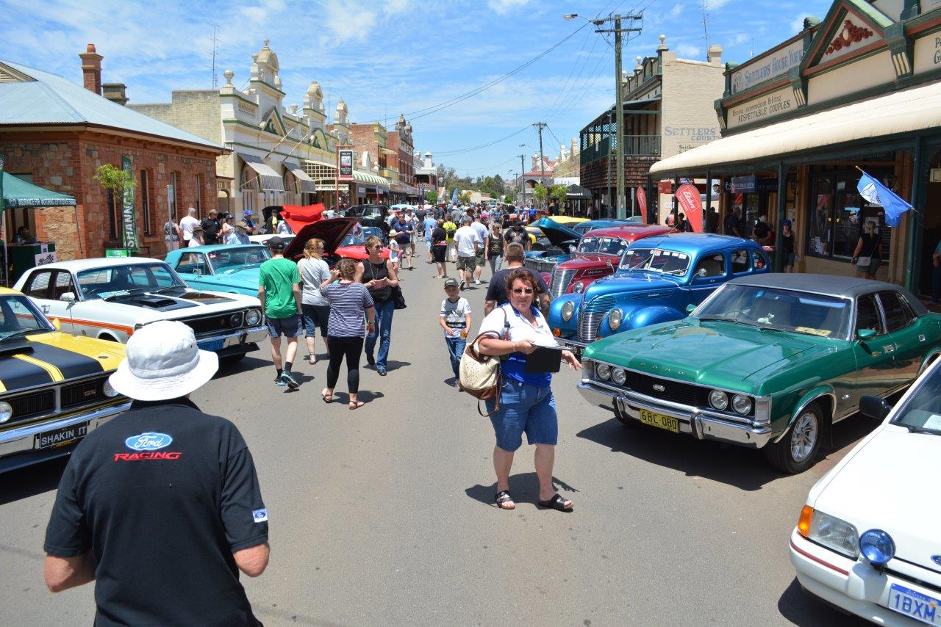
All Ford Day Car Show, Community Funding, 2016

