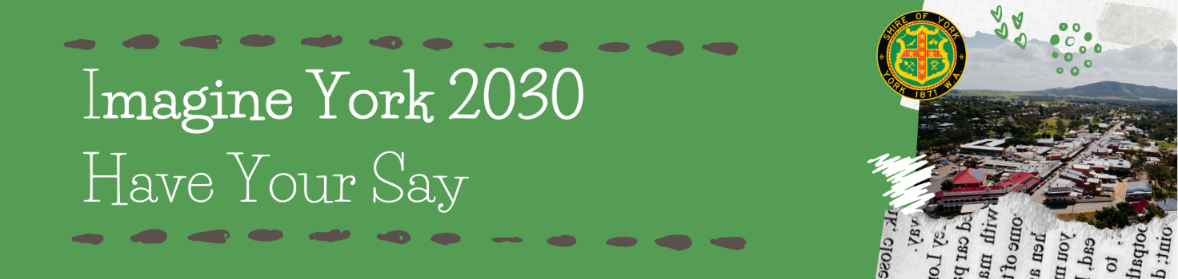

Community Survey
Welcome to the Imagine York 2030 Community Survey! Thank you for taking the time to help set the vision and priorities for the years ahead. The survey takes about ten - fifteen minutes to complete. Your responses are anonymous.
This survey is also available to complete online at www.research.net/r/York_Community_Survey
The survey will close on Sunday 16 February 2020. All hard copy surveys must be returned to the Shire of York Administration Office by 4:30pm on Friday 14 February 2020.

About you
This information will let us know how well survey respondents match the profile of the community. It will also tell us if different groups in the community have different views on the vision and priorities for the coming years.
- How old are you?

0-19
20-29
30-39
40-49
50-59
60-69
70+

- What is your gender?

Male
Female
Other
Prefer not to say

- Please indicate whether you are (tick one only):
A resident in the Shire of York
A business owner in the Shire of York
Both a resident and a business owner in the Shire of York
A non-resident who works for a business in the Shire of York
None of the above

Visioning
We want to know what you love most about this place, what makes it stand out, how you would like York to be in 2030, and top challenges and opportunities facing the community.
- Tell us in a few words what you love most about this place
__________________________________________________________________________________________________________________________________________

- Tell us in a few words what makes York stand out from other places
__________________________________________________________________________________________________________________________________________

- Imagine the Shire of York as you would like it to be in 10 years’ time. What comes to mind? (Please consider things like the economy, social wellbeing, natural environment, townscape and cultural vitality)
__________________________________________________________________________________________________________________________________________

- In your view, what are the biggest challenges facing our community over the next 10 years? (Up to 3)
Challenge 1: _______________________________________________
Challenge 2: _______________________________________________
Challenge 3: _______________________________________________

- In your view, what are the biggest opportunities facing our community over the next 10 years? (Up to 3)
Opportunity 1: ______________________________________________
Opportunity 2: ______________________________________________
Opportunity 3: ______________________________________________

Services and priorities
These questions are asking for your views on services, priorities, role of the Shire, and your big idea for the next ten years.
- Please rate the IMPORTANCE of the following services from your perspective
 | Very unimportant | Unimportant | Neutral | Important | Very important | Not applicable/ no opinion
Roads, Bridges & Drainage
Footpaths & Trails
Swimming Pool
Recreation Facilities & Services
Parks, Open Space & Cemetery
Community Halls & Public Toilets
Shire Buildings & Leases
Community Engagement & Communications
Community Development & Funding
Arts, Culture & Events
Seniors, Disability & Youth Services
Library
Museum
Advocacy & Collaboration
Economic Development, Tourism & Visitor Information Services
Environmental Health
Waste Management
Ranger, Fire & Emergency Services
Environmental management
Town Planning, Heritage Protection & Building Control

- Please rate your SATISFACTION with the following services
 | Very dissatisfied | Dissatisfied | Neutral | Satisfied | Very Satisfied | Not applicable/ no opinion
Roads, Bridges & Drainage
Footpaths & Trails
Swimming Pool
Recreation Facilities & Services
Parks, Open Space & Cemetery
Community Halls & Public Toilets
Shire Buildings & Leases
Community Engagement & Communications
Community Development & Funding
Arts, Culture & Events
Seniors, Disability & Youth Services
Library
Museum
Advocacy & Collaboration
Economic Development, Tourism & Visitor Information Services
Environmental Health
Waste Management
Ranger, Fire & Emergency Services
Environmental management
Town Planning, Heritage Protection & Building Control

- In your view, what top three priorities should the Shire focus on in the next four years?
Priority 1: _________________________________________________
Priority 2: _________________________________________________
Priority 3: _________________________________________________
- I would be willing to pay a small amount more in rates if the Shire spent it on...
There is nothing I would be willing to pay a small amount more in rates for
Please specify what you would be willing to pay a small amount more in rates for
_____________________________________________________________
- I would be willing to forego the following service to minimise rates...
There is no service I would be willing to forego to minimise rates
Please specify what service you would be willing to forego to minimise rates
_____________________________________________________________
- What is your Big Idea for York in the next ten years?
Improved streetscapes
More support for events
Development of trails and other tourist attractions
A new community facility or other big idea (please specify)
__________________________________________________________
- What is the Shire’s most important role in improving your experience of living in York?
__________________________________________________________________________________________________________________________________________

Some specific questions
The Council is seeking community feedback on the following two specific issues.
- What should the Shire do to support building owners to help maintain the character of the Town?
__________________________________________________________________________________________________________________________________________

- What is one thing the Shire could do to support existing businesses and/or encourage new business?
__________________________________________________________________________________________________________________________________________

One thing that money can't buy
We want to hear your innovative ideas for how the Shire and community could achieve improvements without spending a lot of money.
- What is one thing that the Shire and community could achieve at nil/low cost?
__________________________________________________________________________________________________________________________________________

