UNCONFIRMED MINUTES
Access and Inclusion Advisory Committee Meeting
Wednesday, 4 August 2021
Date: | Wednesday, 4 August 2021
Time: | 2.00pm
Location: | Council Chambers, York Town Hall, York

Order Of Business
1 Opening 3
1.1 Declaration of Opening 3
1.2 Disclaimer 3
1.3 Standing Orders 3
1.4 Announcement of Visitors 3
1.5 Declarations of Interest that Might Cause a Conflict 3
1.6 Declaration of Financial Interests 3
1.7 Disclosure of Interests that May Affect Impartiality 3
2 Attendance 3
2.1 Members 3
2.2 Staff 3
2.3 Apologies 4
2.4 Leave of Absence Previously Approved 4
3 Applications For Leave of Absence 4
4 Presentations 4
5 Confirmation of Minutes of Previous Meetings 4
6 Announcements by Presiding Member Without Discussion 4
7 Officer's Reports 5
7.1 Review of the AIAC Terms of Reference 5
8 Questions from Members without Notice 26
9 Business of an Urgent Nature Introduced by Decision of the Meeting 26
10 Closure 26

MINUTES OF Shire Of York
Access and Inclusion Advisory Committee Meeting
HELD AT THE Council Chambers, York Town Hall, York
ON Wednesday, 4 August 2021 AT 2.00pm

The Access and Inclusion Advisory Committee acknowledges the traditional owners of the land on which this meeting is held.

1 Opening

1.1 Declaration of Opening
Mrs Bev Penny, Presiding Member, declared the meeting open at 2.04pm.

1.2 Disclaimer
The Presiding Member advised the following:
“I wish to draw attention to the Disclaimer Notice contained within the agenda document and advise members of the public that any decisions made at the meeting today, can be revoked, pursuant to the Local Government Act 1995.
Therefore members of the public should not rely on any decisions until formal notification in writing by Council has been received. Any plans or documents in agendas and minutes may be subject to copyright. The express permission of the copyright owner must be obtained before copying any copyright material.”

1.3 Standing Orders
Nil

1.4 Announcement of Visitors
Nil

1.5 Declarations of Interest that Might Cause a Conflict
Nil

1.6 Declaration of Financial Interests
Nil

1.7 Disclosure of Interests that May Affect Impartiality
Nil

2 Attendance

2.1 Members
Mrs Bev Penny; Cr Jane Ferro; Cr Kevin Trent; Mrs Liz Christmas; Mrs Sarah Sloss; Mrs Marie Forster; Mrs Marjorie Kerkhoff

2.2 Staff
Jo Bryant, YRCC Project Officer; Alina Behan, Executive Manager Corporate & Community Services

2.3 Apologies
Mrs Teagan Walsh; Mrs Rosemary Parker

2.4 Leave of Absence Previously Approved
Nil

3 Applications For Leave of Absence
Nil

4 Presentations
Nil

5 Confirmation of Minutes of Previous Meetings
COMMITTEE RECOMMENDATION
Moved: Mrs Liz Christmas Seconded: Cr Kevin Trent
That the minutes of the Access and Inclusion Advisory Committee Meeting held on 5 May 2021 be confirmed as a correct record of proceedings.
Carried: 7/0

6 Announcements by Presiding Member Without Discussion
The Presiding Member advised the Committee that she attended the Black Swan production ‘YORK’ at the Heath Ledger Theatre.
The Presiding Member also referenced Carers WA who visit York every few weeks in front of the Community Resource Centre to help people access information and support.

7 Officer's Reports

7.1 Review of the AIAC Terms of Reference
File Number: | OR.CMA.9.1
Author: | Joanna Bryant, Project Officer
Authoriser: | Alina Behan, Executive Manager Corporate & Community Services
Previously before Council: | Not Applicable
Appendices: | 1. Appendix 1: Terms of Reference – proposed amendments  2. Appendix 2: Policy E1 - Code of Conduct

Nature of Council’s Role in the Matter
Executive

Purpose of Report
This report presents a review of the Access & Inclusion Advisory Committee’s Terms of Reference and suggested amendments.

Background
At the 5 May 2021 Access & Inclusion Advisory Committee meeting the Presiding Member requested a review of the Terms of Reference to ensure they are current and relevant. The Executive Manager agreed to investigate and prepare a report for the August meeting.

Comments and Details
The Shire of York has developed a Disability Access and Inclusion Plan (DAIP). The Disability Services Act 1993 requires that agencies undertake public consultation during the development and delivery of their DAIPs. The establishment of an Access & Inclusion Advisory Committee with community membership allows a mechanism for ongoing Community engagement with regard to the delivery and review of the DAIP.
The Access and Inclusion Committee is a Committee of Council established under Part 5 – Division 2 (Subdivision 2) of the Local Government Act 1995 – Committees and their meetings with its own discrete Terms of Reference.
The Terms of Reference do not define the conduct expected of Committee Members. The Access and Inclusion Advisory Committee is subject to Policy E1 - Code of Conduct: Council Members, Committee Members & Candidates (Appendix 2) as set by Council in accordance with Section 2.7(2) of the Local Government Act 1995.
The existing Terms of Reference do not define the requirement to attend meetings. Regular attendance at meetings assists with both the continuity of understanding and progressing of issues. As the Committee meets quarterly, Officers recommend that Committee Members are required to attend a minimum of two meetings a year.
Officers recommend the addition of new clause to provide clarity to committee members around both conduct and attendance requirements as below:
7.3 Reasons for removal of Membership
In accordance with Section 2.7(2) of the Local Government Act 1995, Council determines the Shire’s policies and the Access and Inclusion Advisory Committee is subject to Policy E1 - Code of Conduct: Council Members, Committee Members & Candidates.
Members may be removed from the Access & Inclusion Committee if they do not abide by the general principles to guide the behaviour of committee members listed in the Code of Conduct policy.
Committee Members are required to attend in person a minimum of two meetings per financial year. Members unable to meet this minimum requirement may be removed from the Access & Inclusion Committee.
Appendix 1: Terms of Reference – proposed amendments Aug 2021 shows the Terms of Reference including the proposed additional clause 7.3.

Options
Option 1: The Committee could recommend Council request the CEO to amend the Terms of Reference as per the proposed revision to clarify the conduct and attendance requirements.
Option 2: The Committee could choose not to recommend Council request the CEO to amend the Terms of Reference.
Option 1 is the recommended option

Implications to Consider

Consultative
Executive Leadership Team

Strategic
Goal 5: Strong Leadership and Governance
To have effective and responsive leadership and governance, where a sense of collective purpose and shared direction combine to work together.

Policy Related
E1 – Code of Conduct – Council Members – Committee Members – Candidates

Financial
N/A

Legal and Statutory
Local Government Act 1995
The Access and Inclusion Committee is established under Part 5 – Division 2 (Subdivision 2) of the Local Government Act 1995 – Committees and their meetings. No authority is delegated to the Committee and all recommendations made by the Committee will be brought to Council for decision.

Risk Related
By enabling consistent external representation to the Committee, it can be considered the level of risk is reduced due to greater transparency and oversight.

Workforce
N/A

Voting Requirements
Not applicable.

Recommendation
That, with regard to the Access & Inclusion Terms of Reference, the Committee recommends that Council:
1. Requests the Chief Executive Officer to amend the Terms of Reference, as per the proposed revision presented in Appendix 1, to clarify the conduct and attendance requirements.
Marie Forster introduced an Alternate Motion to the Officer’s recommendation.

COMMITTEE RESOLUTION
Moved: Mrs Marie Forster Seconded: Mrs Liz Christmas
That, with regard to the Access & Inclusion Terms of Reference, the Committee:
        - Postpones voting on the recommended review of the Terms of Reference.
        - Holds a workshop for the Committee to input to the Terms of Reference review.
carried 6/1

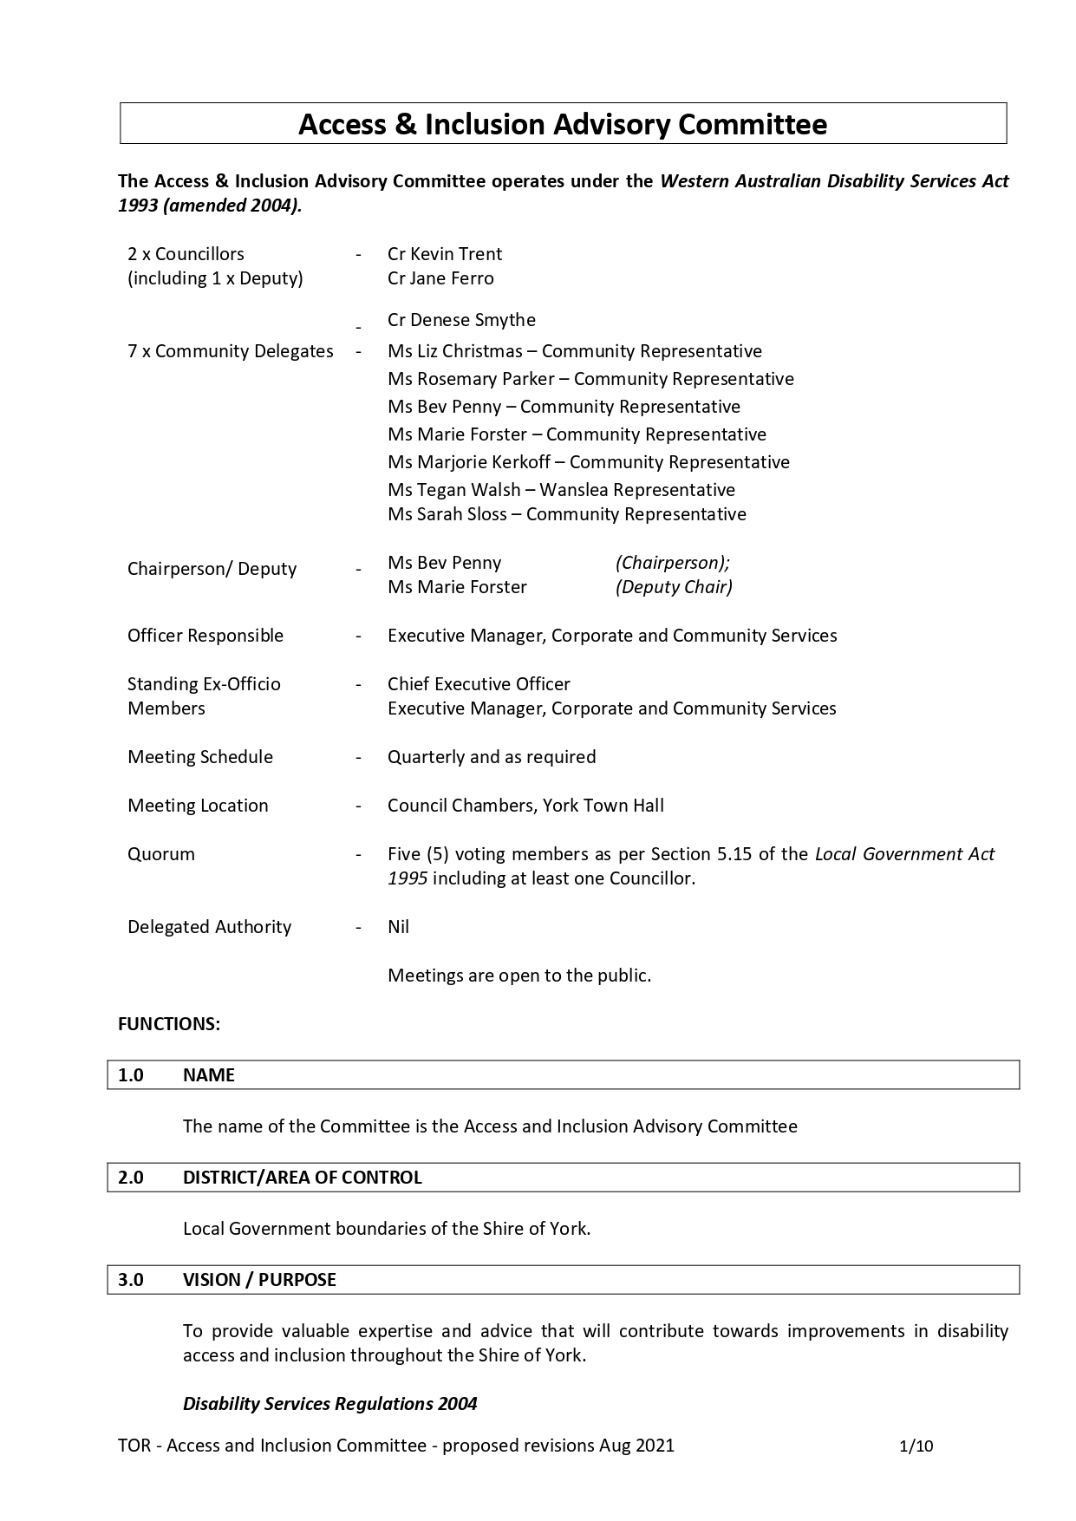
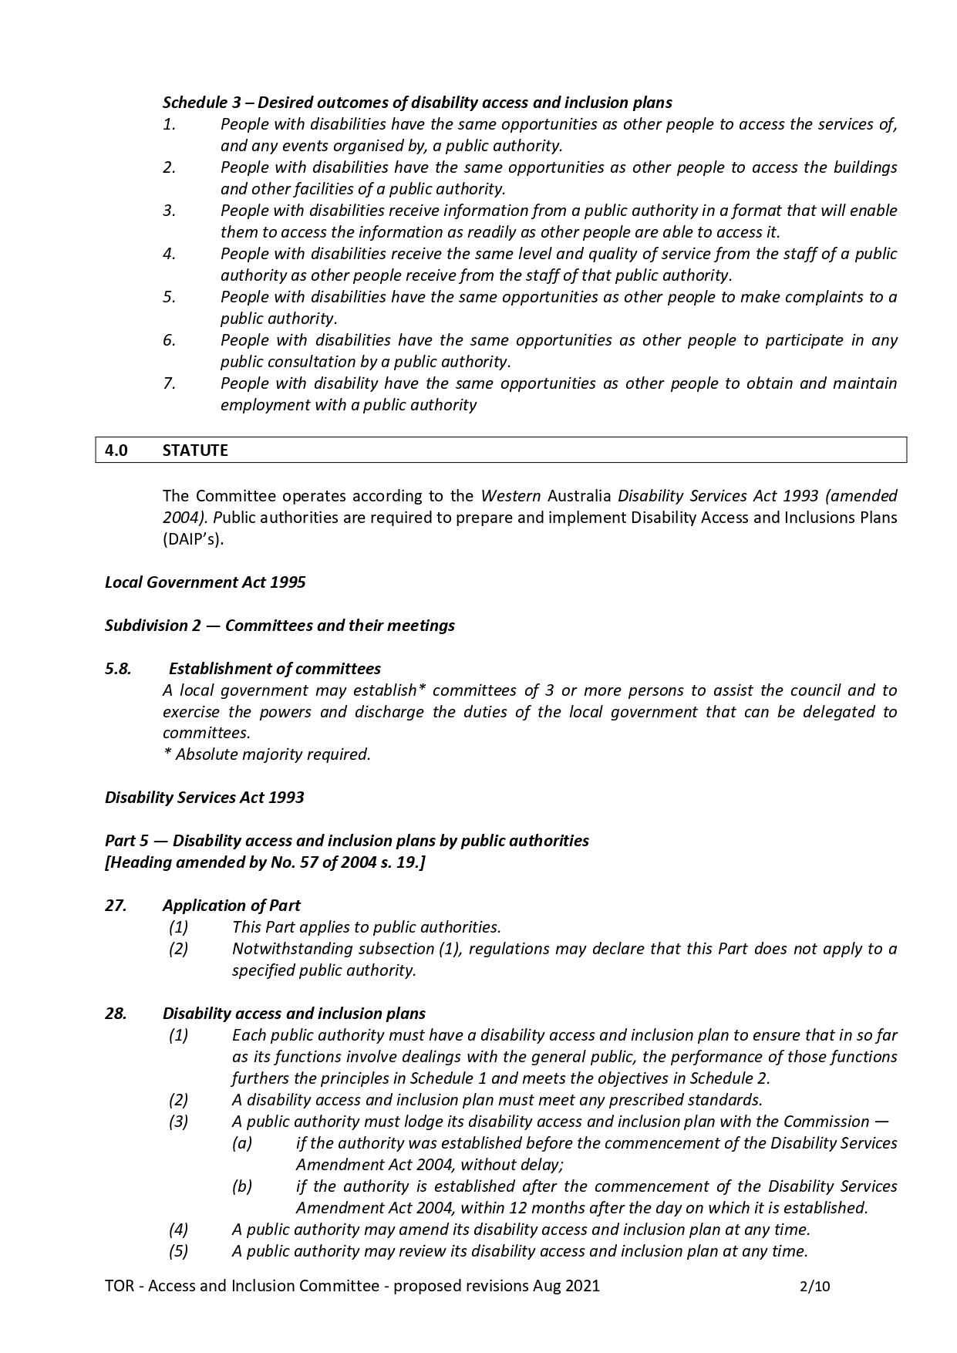
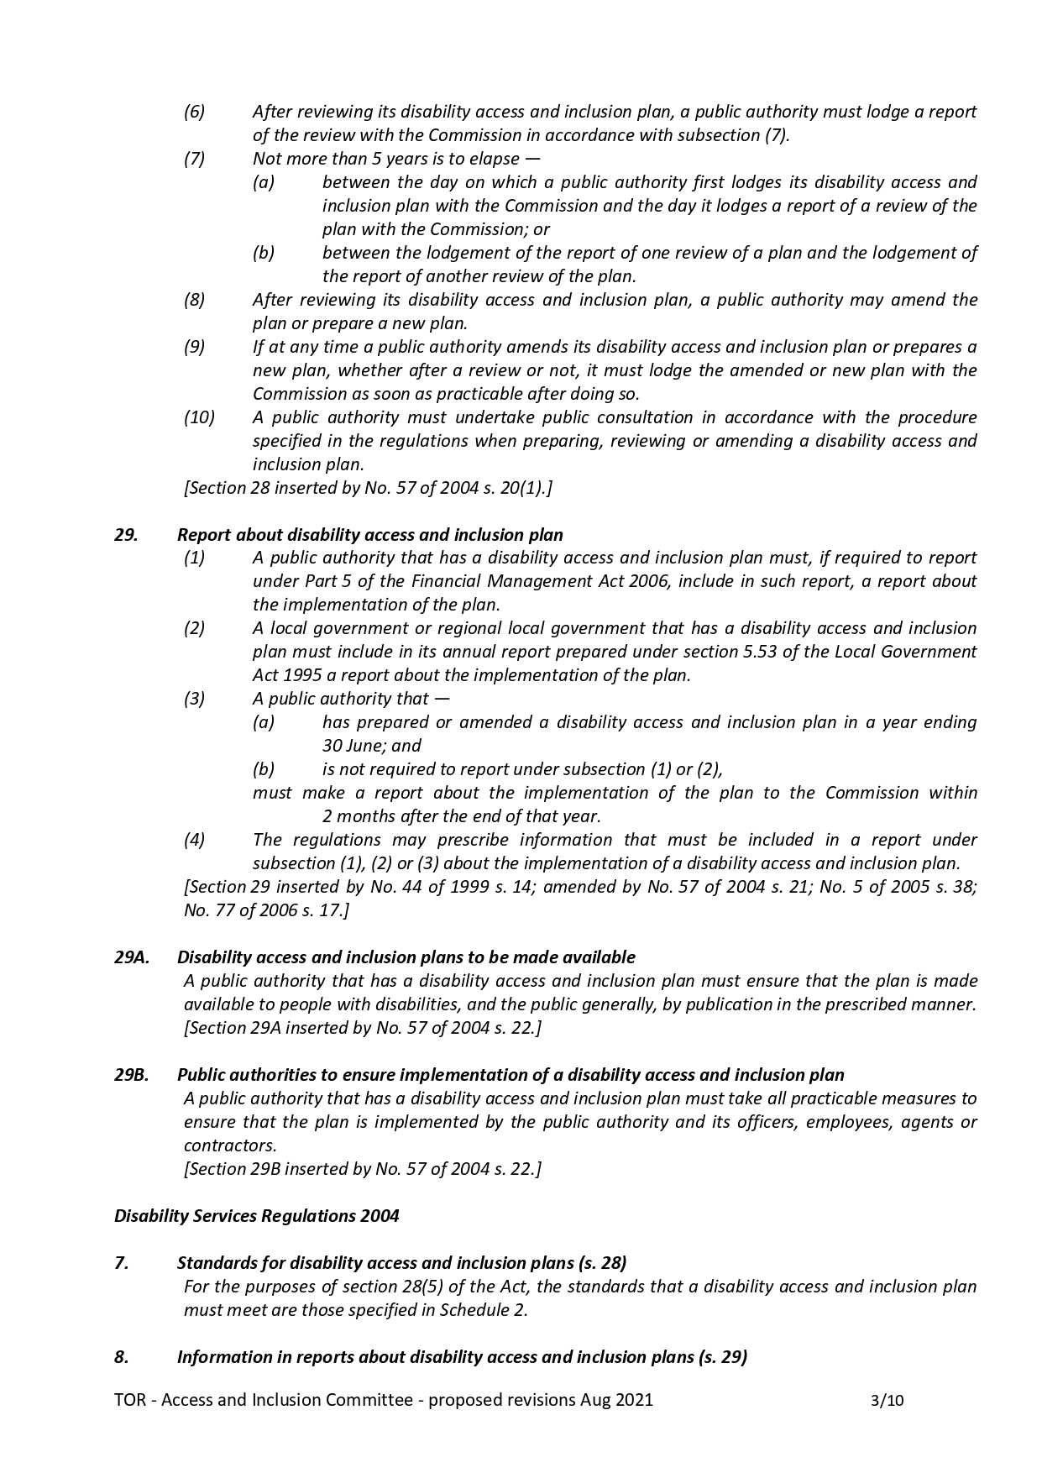
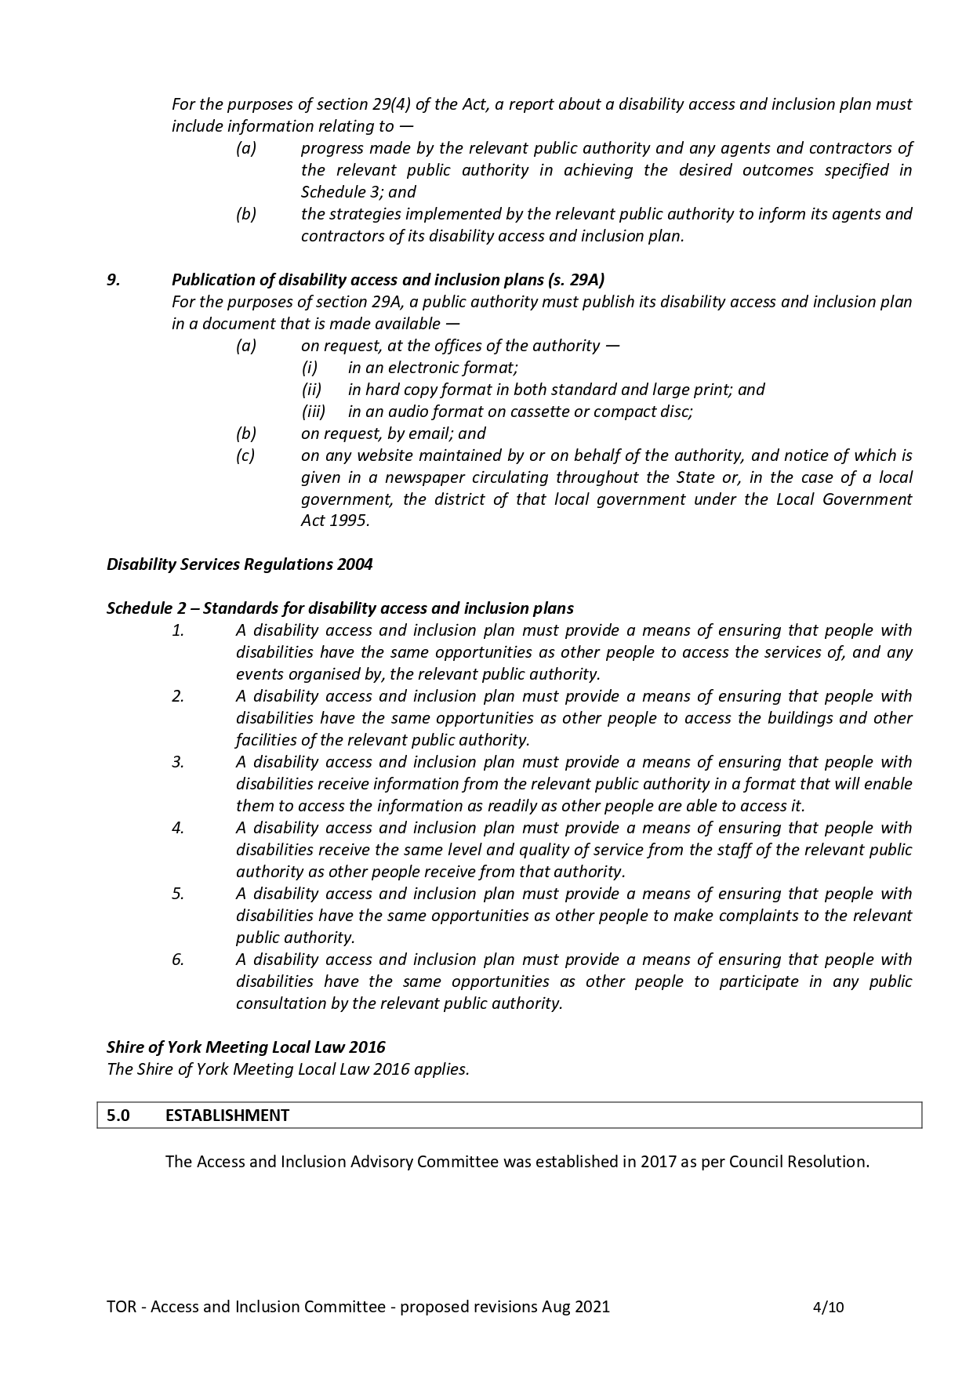
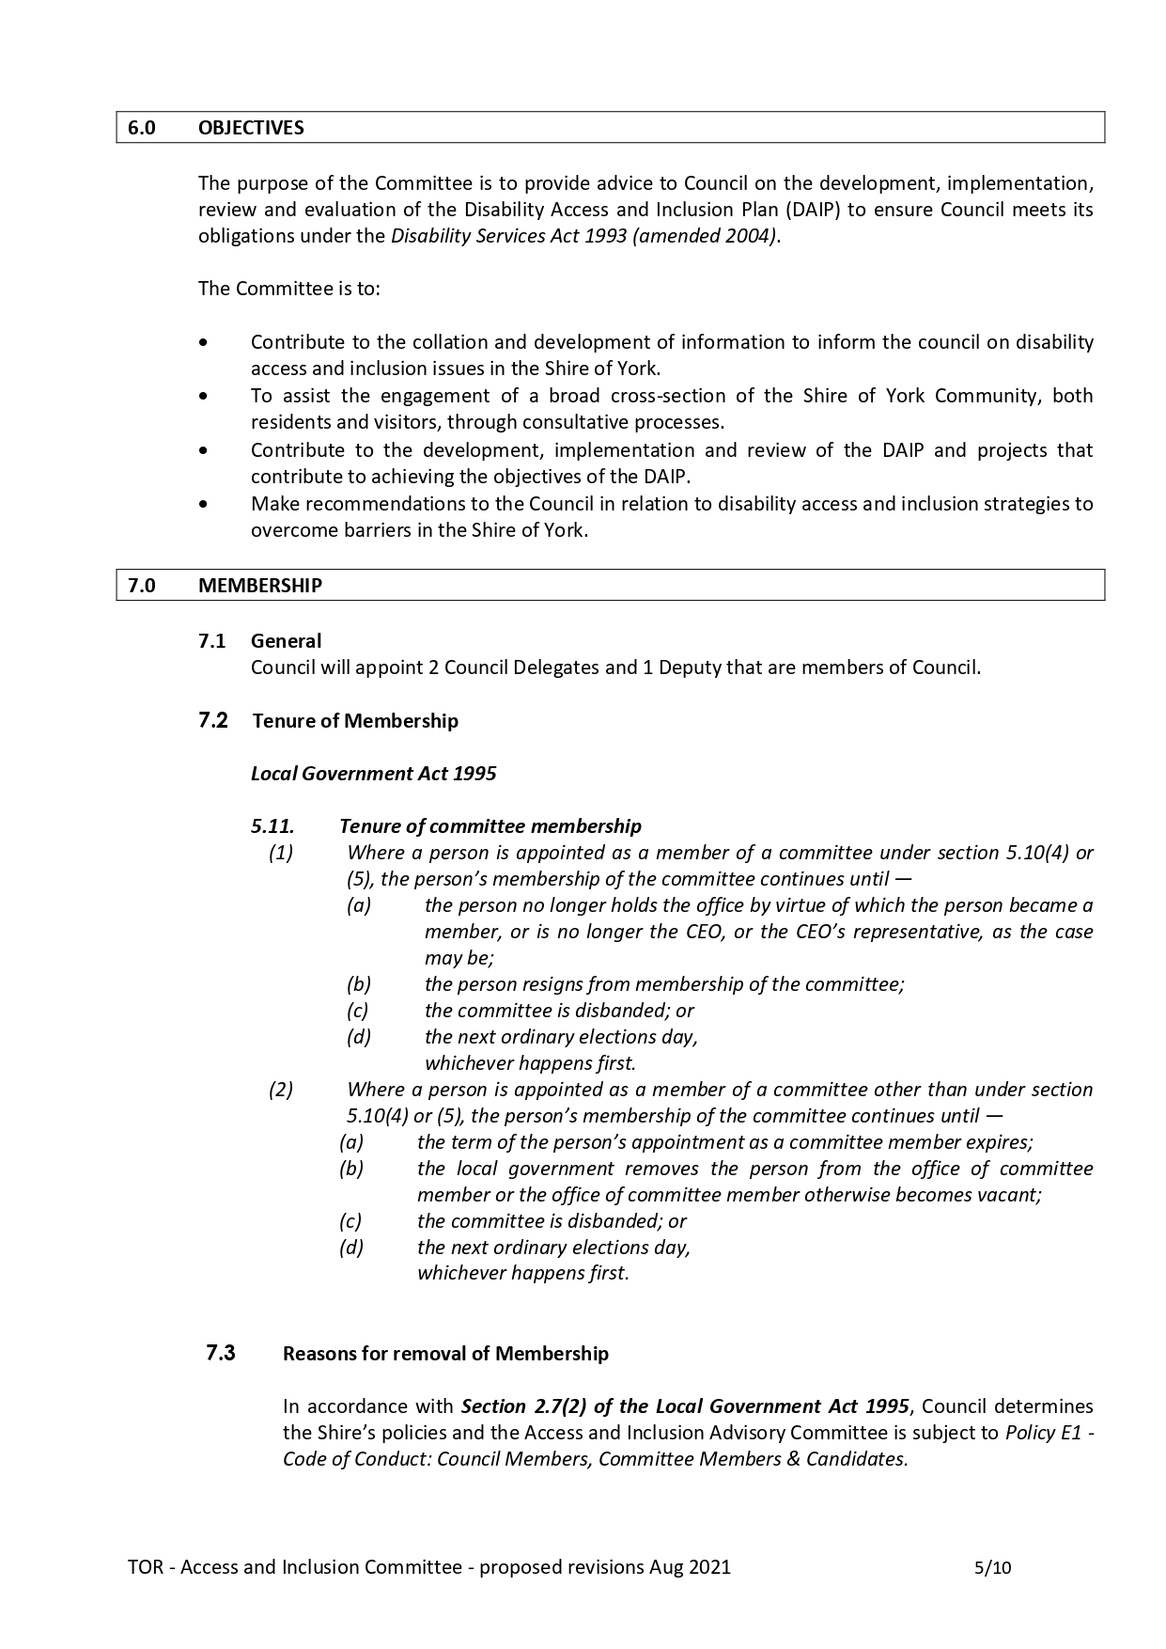
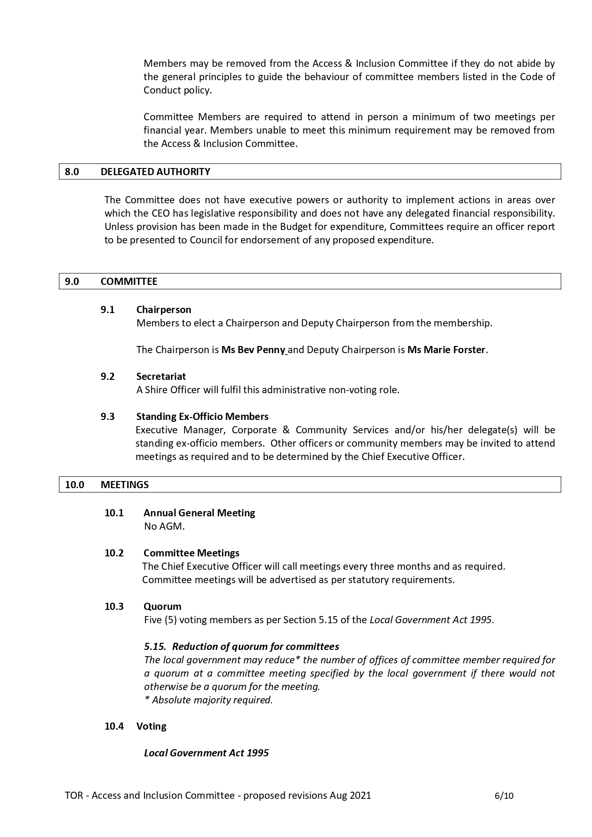
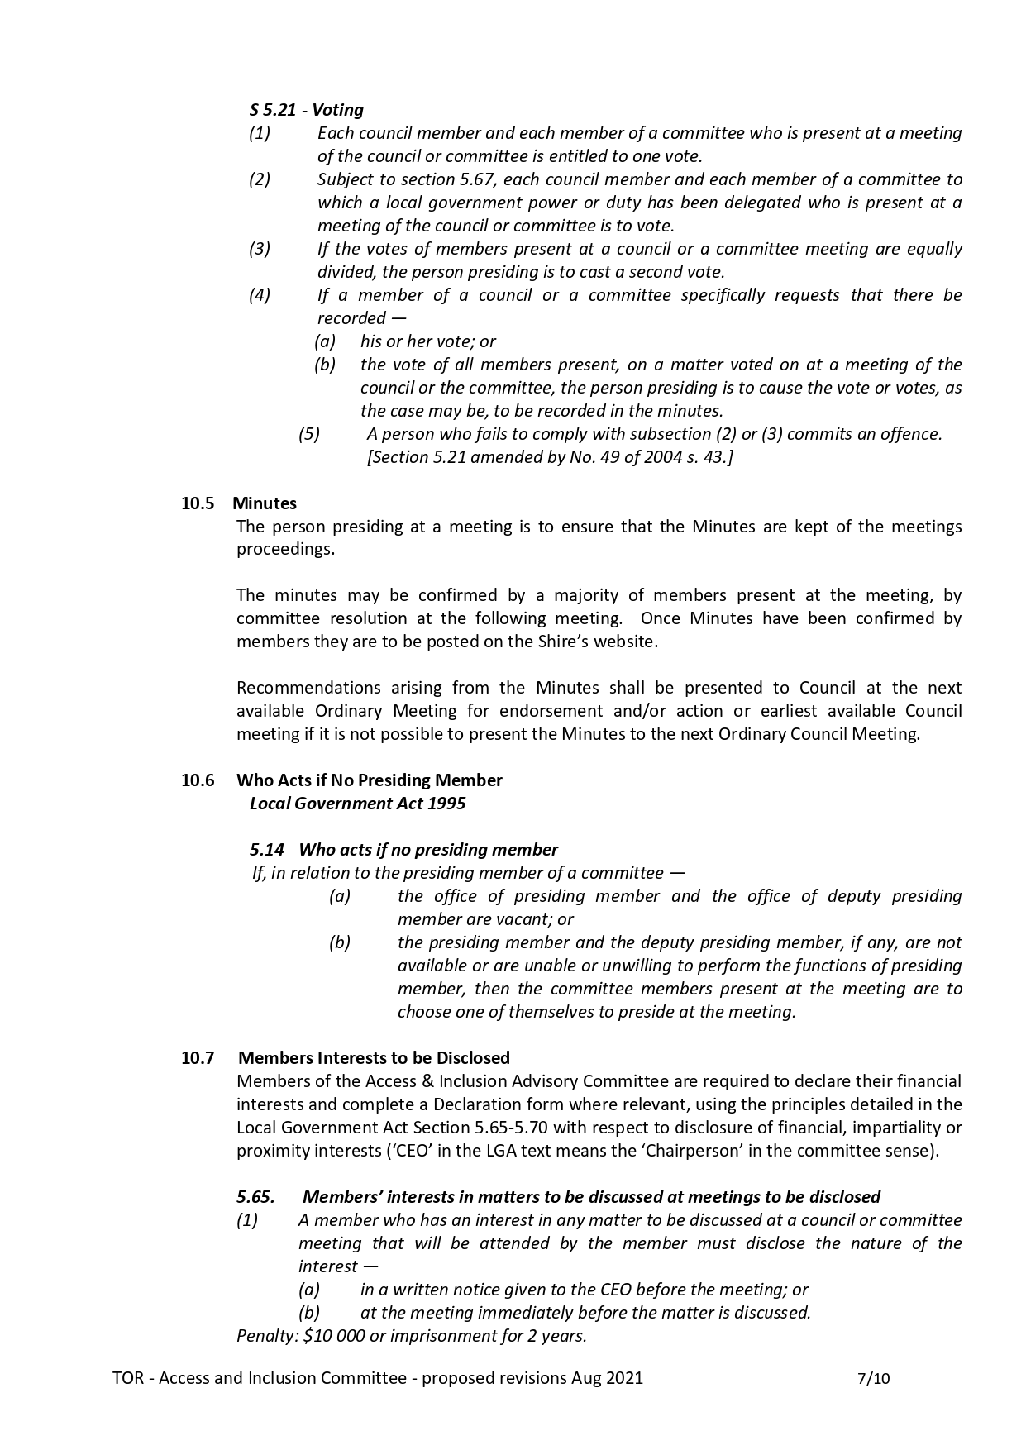
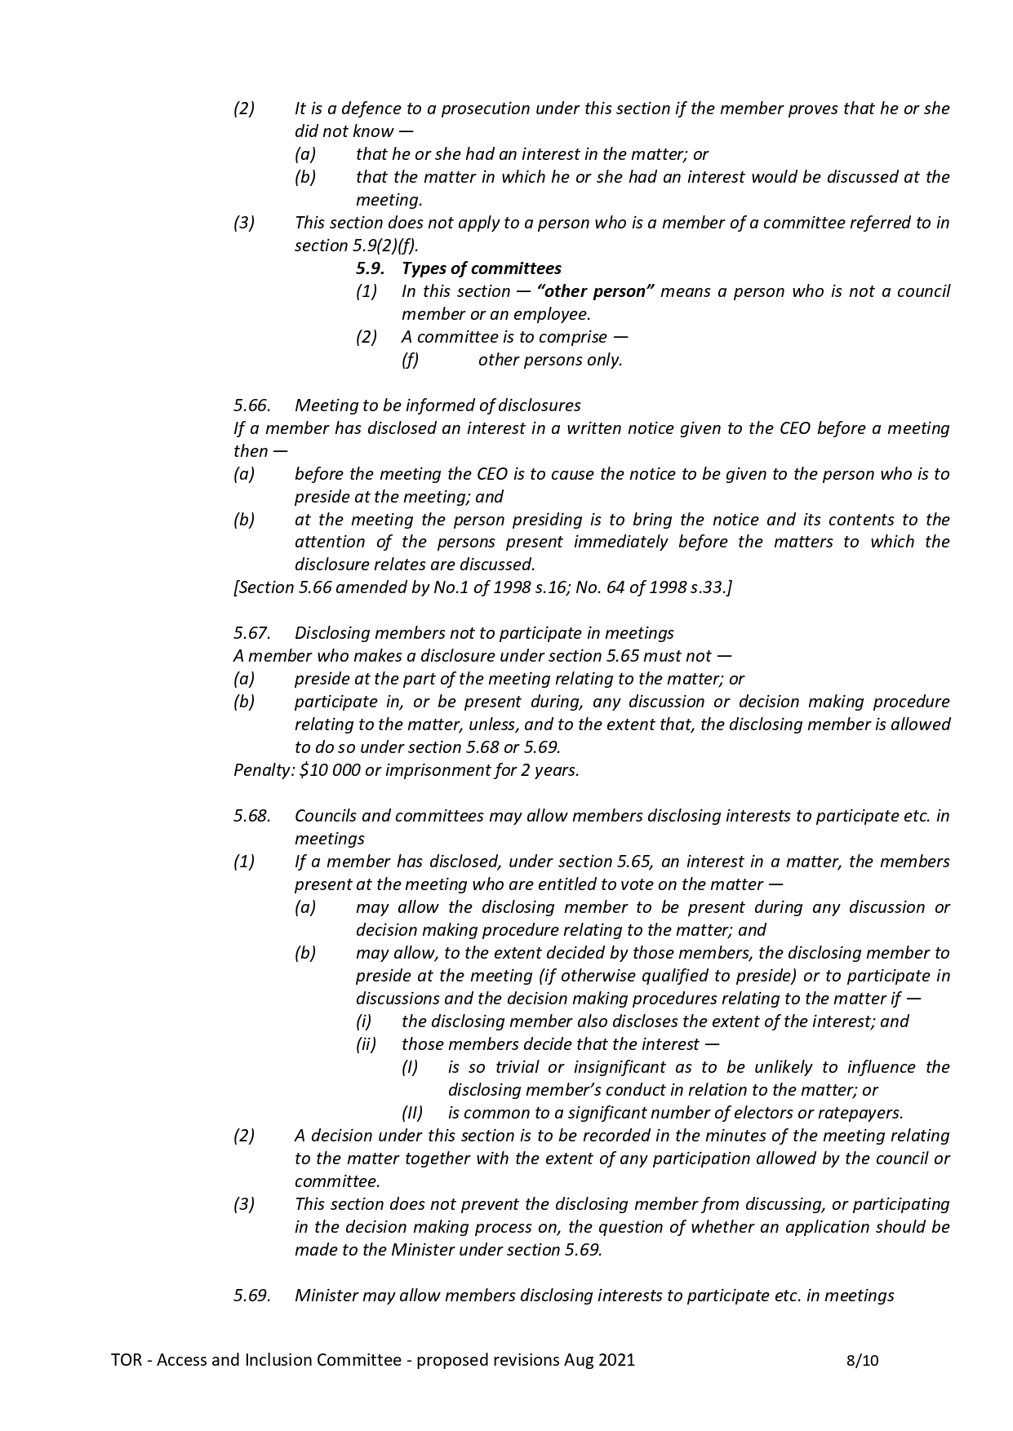
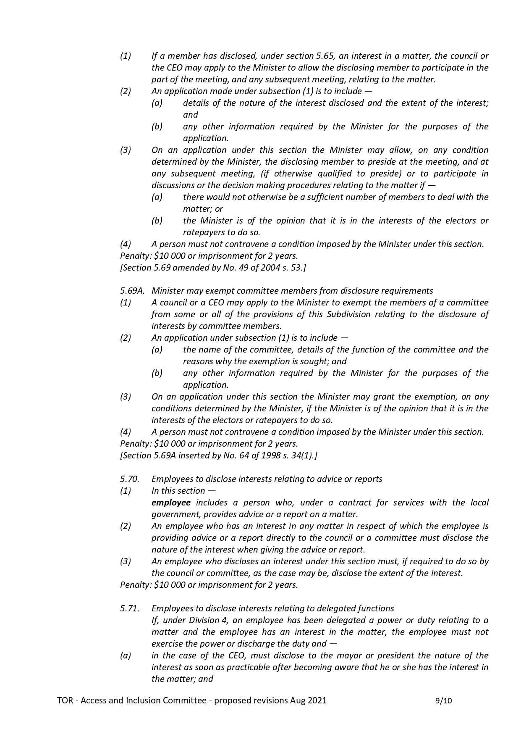

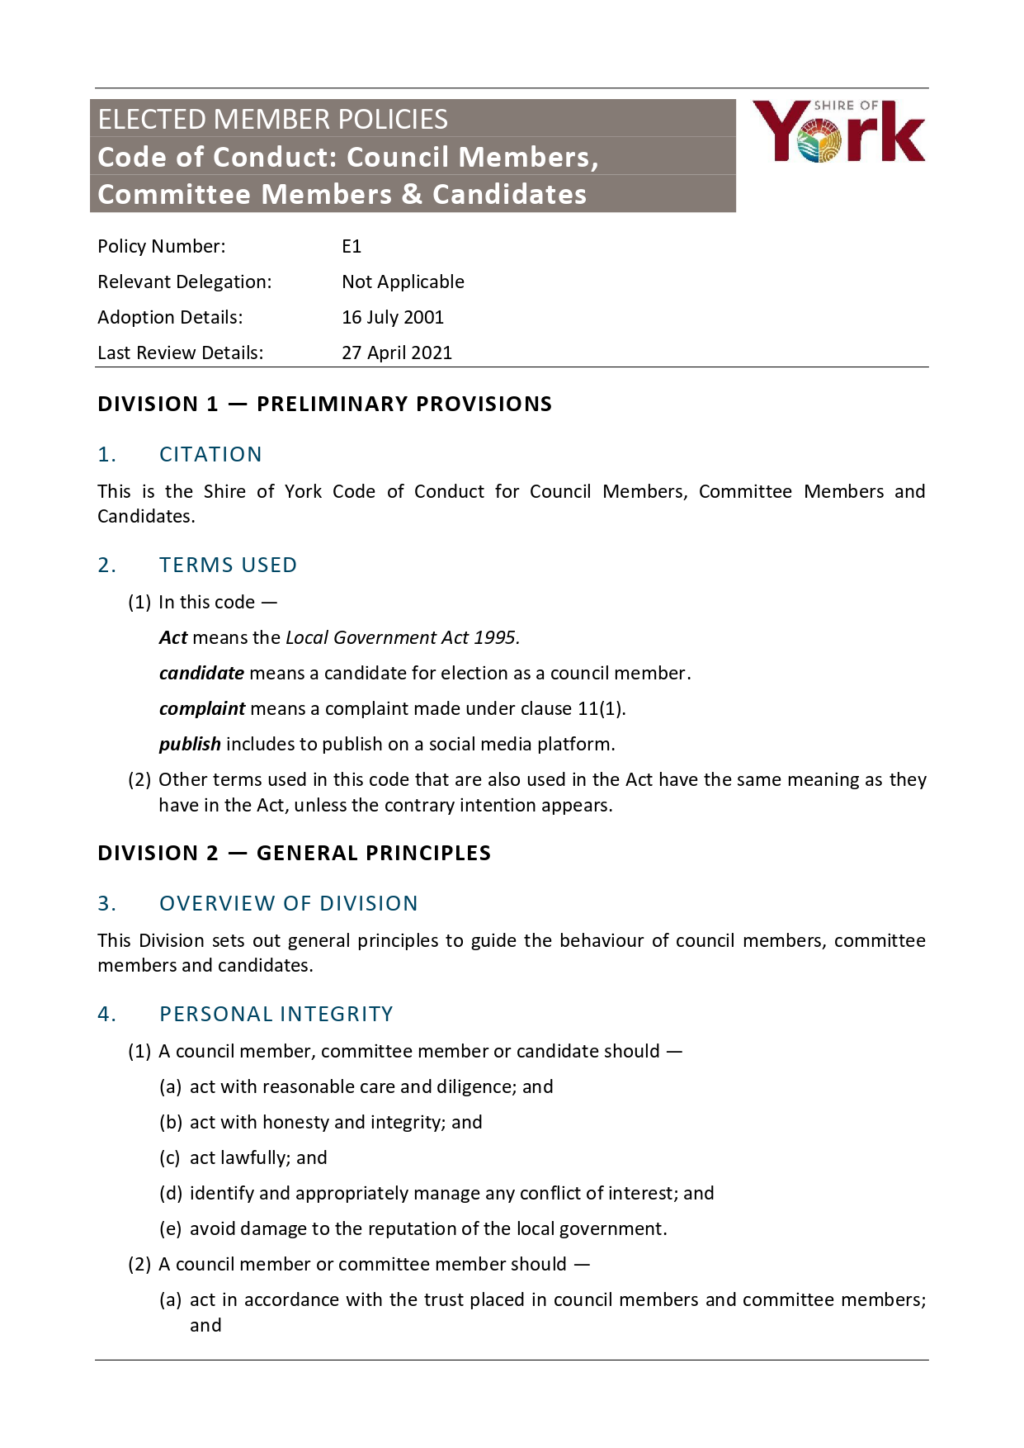
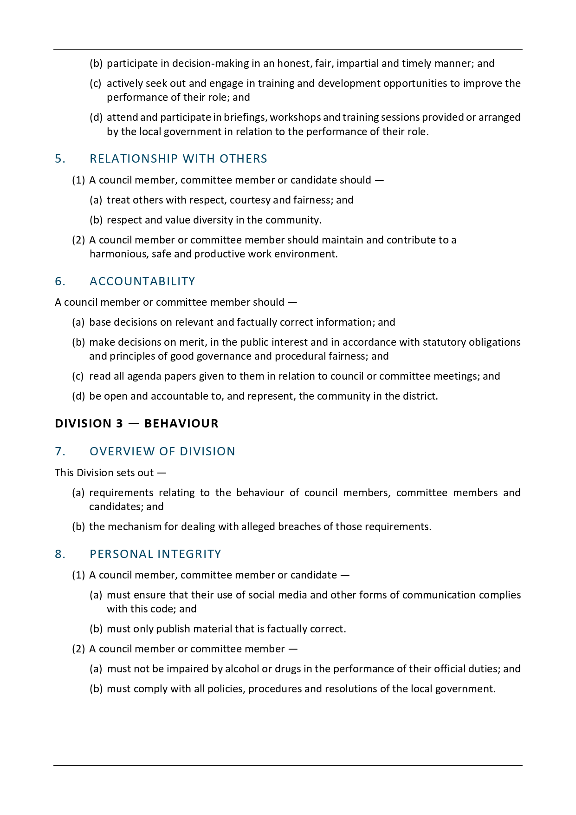
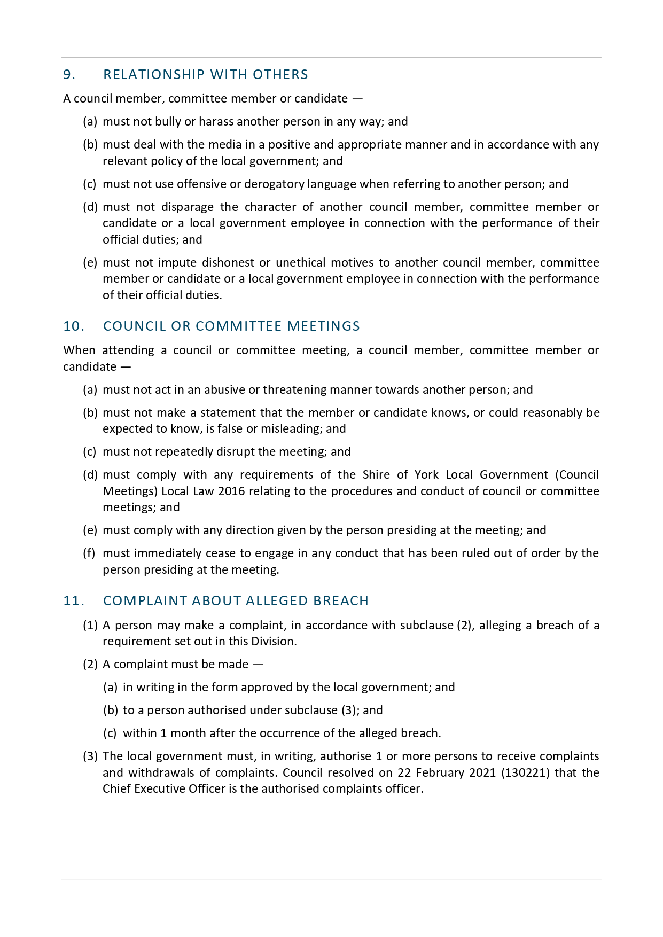
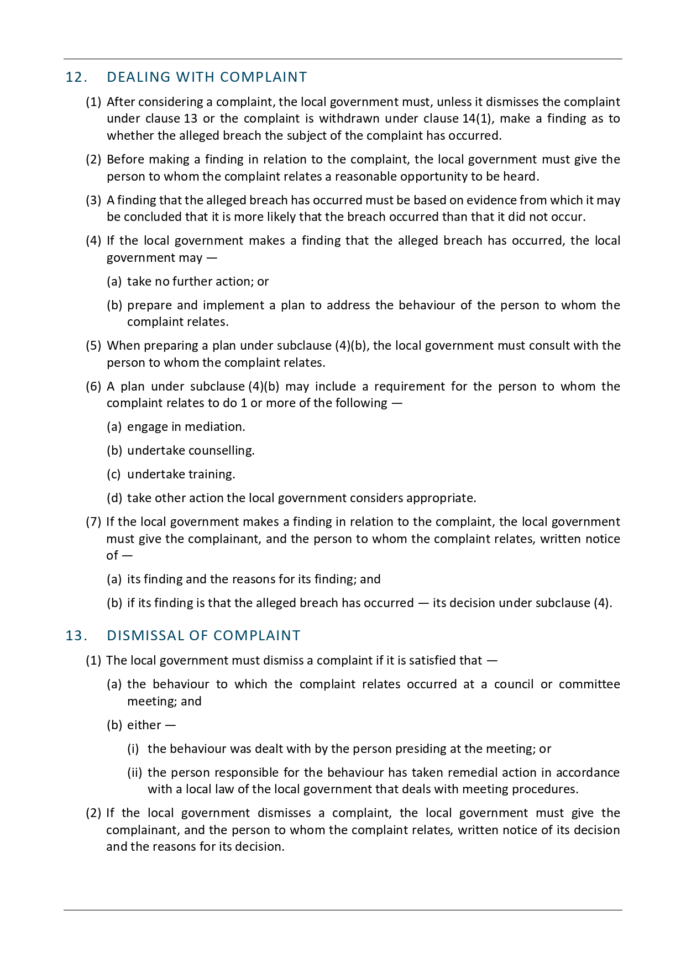
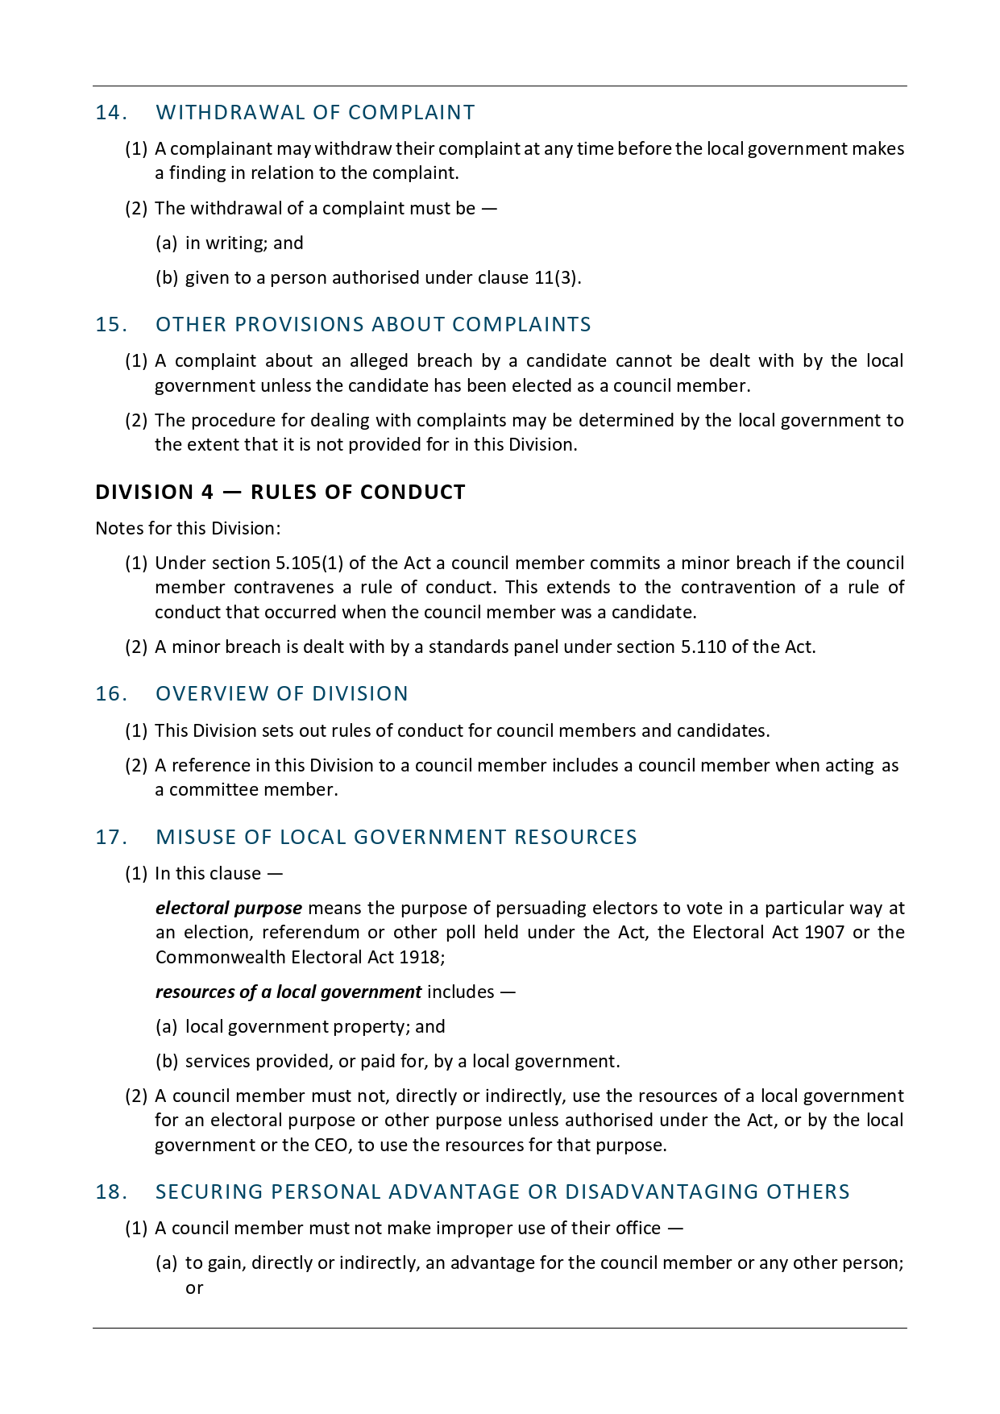
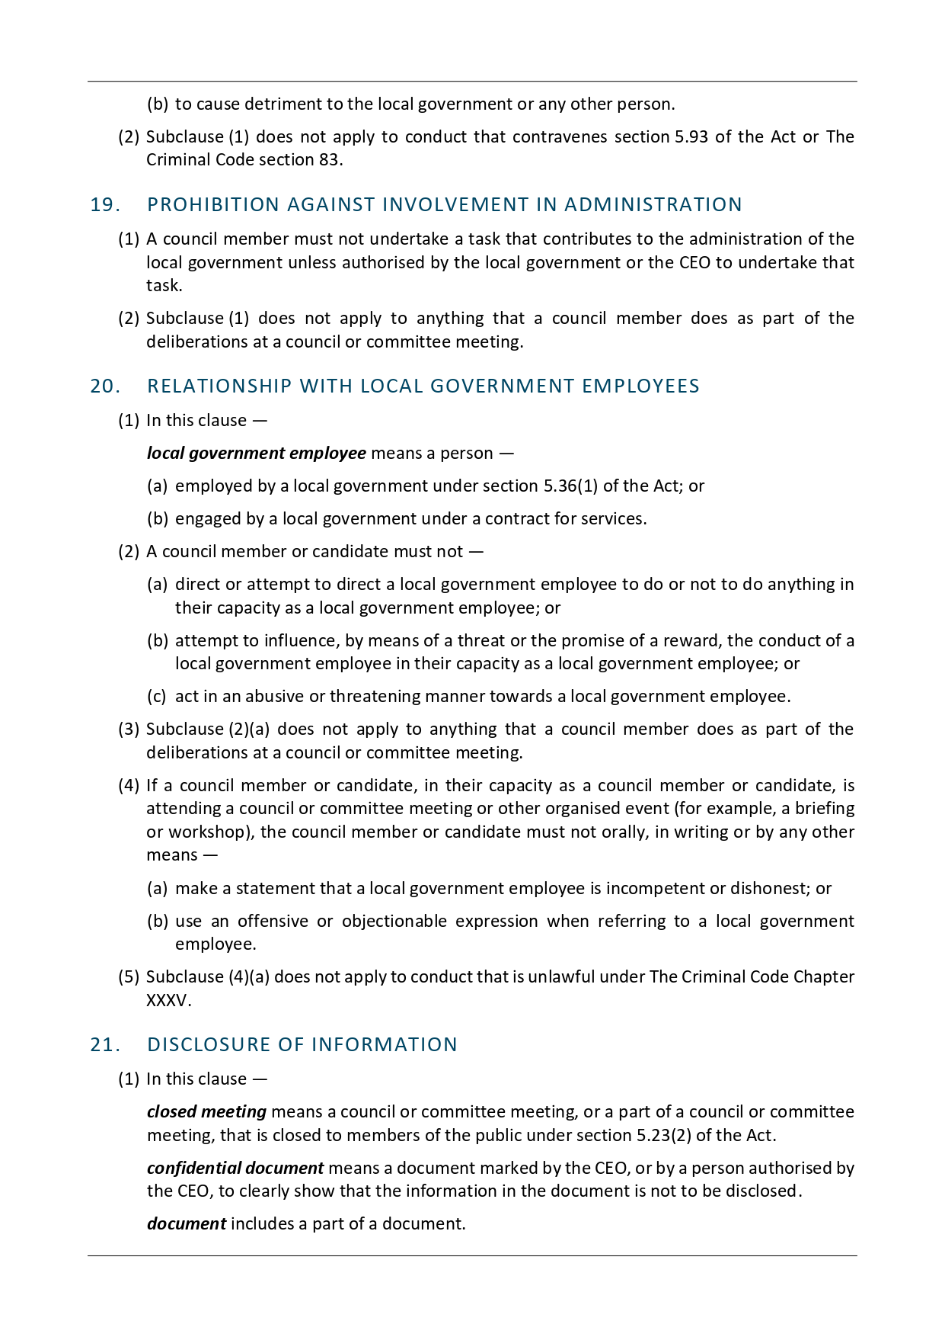
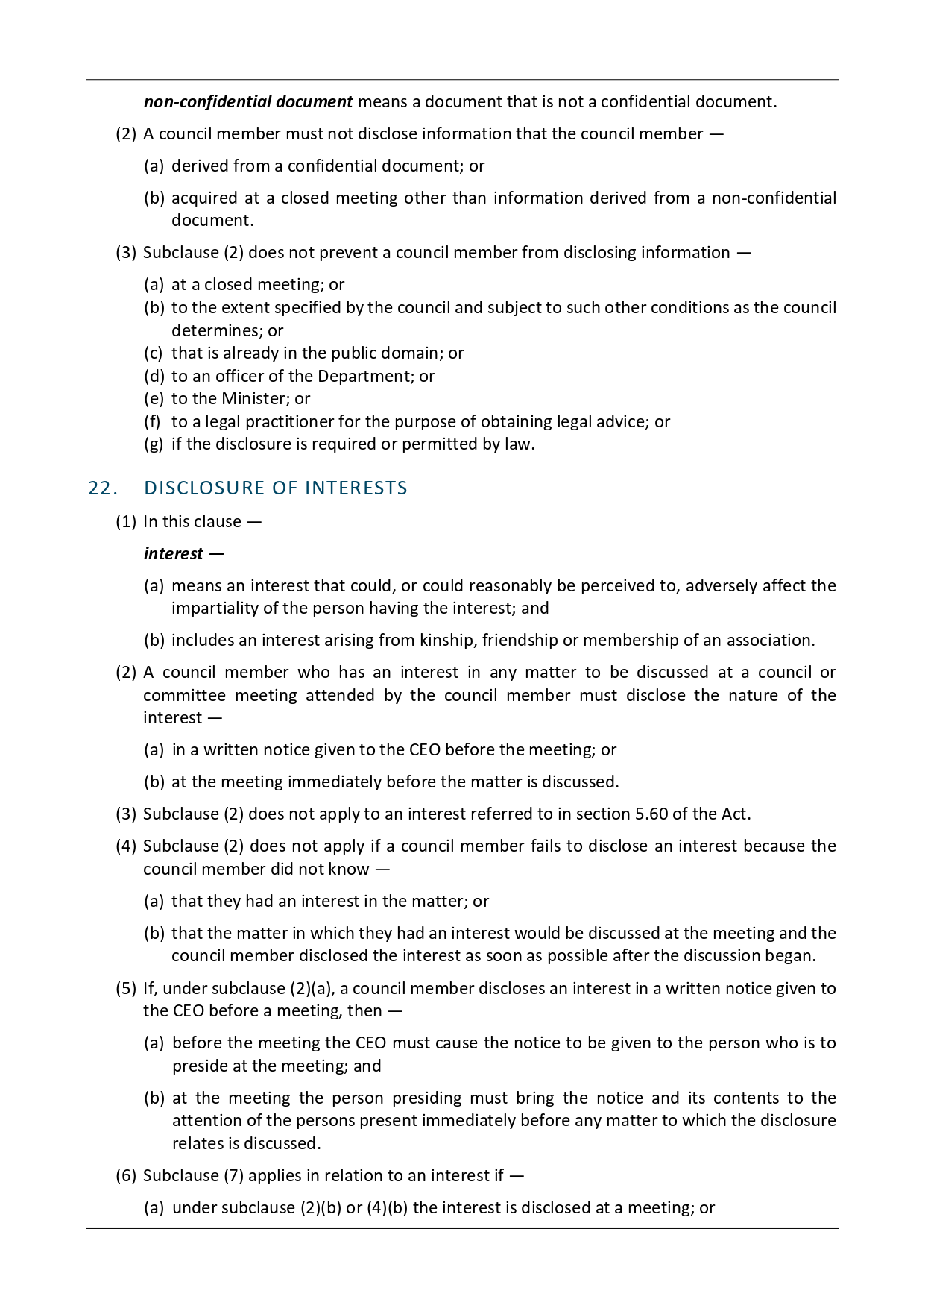
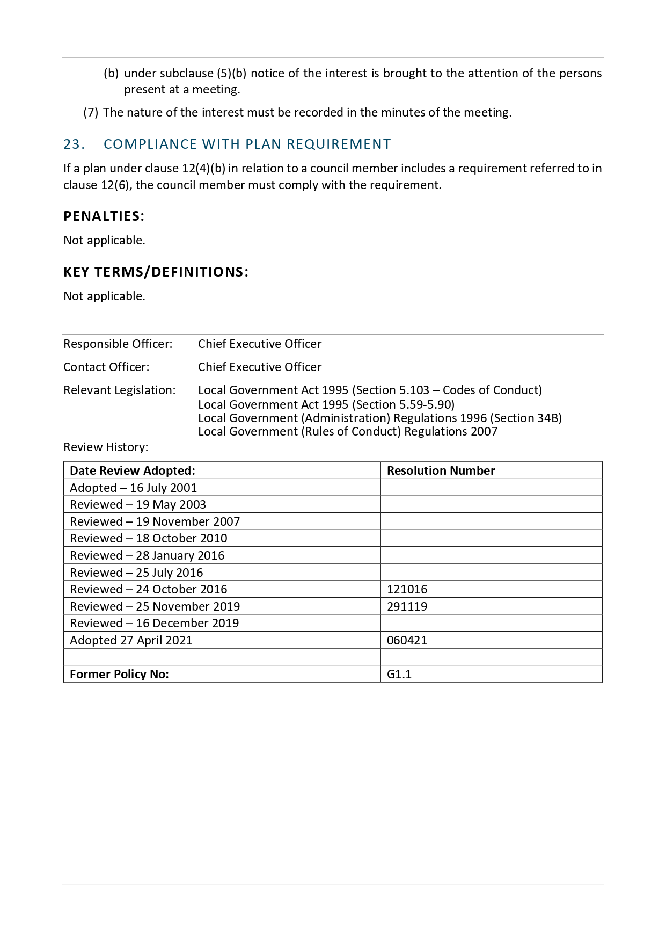

8 Questions from Members without Notice
Liz Christmas
Will the Committee be invited to contribute to the consultation regarding the Public Health Plan?

The EMCCS confirmed that the Committee would be included in the invites to contribute.

Marie Forster
Addressed to the Presiding Member: Were you involved in the conversation regarding updating the Terms of Reference?

The Presiding Member advised that she was not involved.

With regard to the updates to the Terms of Reference, was any research done as to what the barriers to attendance could be? Is there any plan to make the meetings more accessible, perhaps by allowing virtual attendance via Zoom or similar?

The EMCCS confirmed that during COVID-19 legislation was altered to allow Council to meet virtually. Officers will investigate the current legislation.

Sarah Sloss
Can the Acknowledgement of Country please be included at the start of the meeting.

The EMCCS confirmed that the Acknowledgement should be read.

9 Business of an Urgent Nature Introduced by Decision of the Meeting
Nil

10 Closure
The Presiding Member thanked everyone for their attendance and closed the meeting at 2.30pm.

